

AI Assisted Problem Solving Using Python

AcademicYear:2025-2026

|  |
| --- |
| Assignment Type: Lab  Assig_No. 1 |

Submitted by:

Name: Kassim Sesay

Enrol No. 2503B05101

Course: M.tech data Science

Submitted to:

Name: Venkataramana Veeramsetty

Title: Course Instructor

Date: 27 Oct 2025

Q 2**: Use Copilot to generate a is_prime() Python function.**

Code:

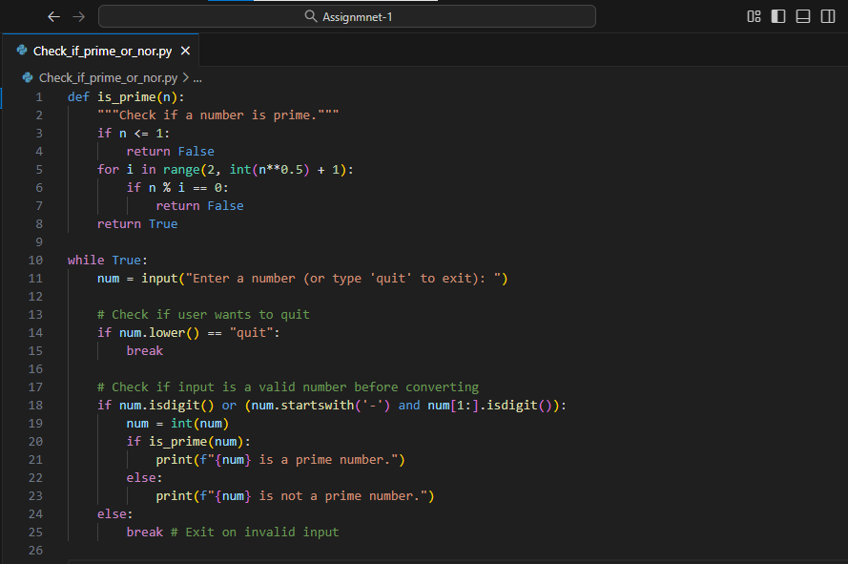

**Output screenshot:**

Function to check primality with correct logic.

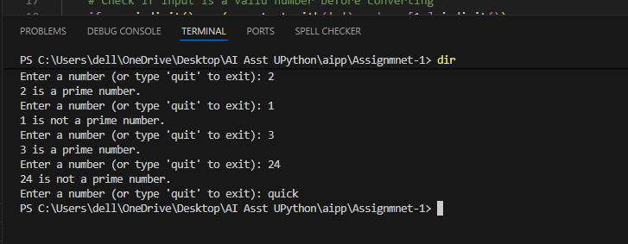

Q 3: **Write a comment like # Function to reverse a string and use Copilot to generate the function.**

Code:

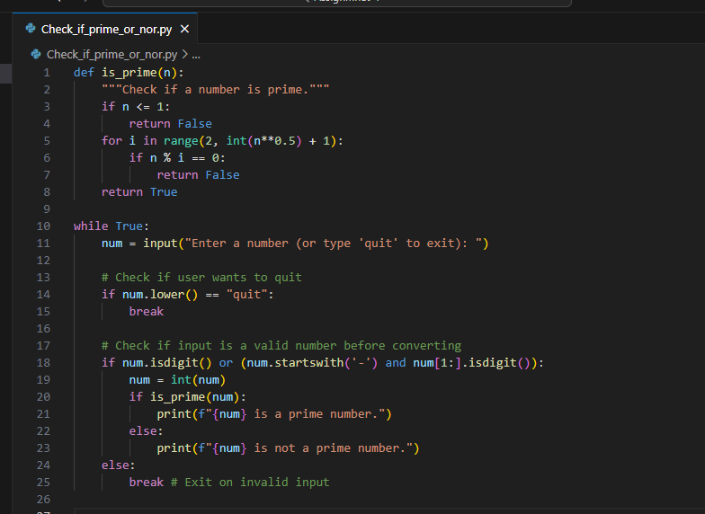

**Output: Auto-completed reverse function**

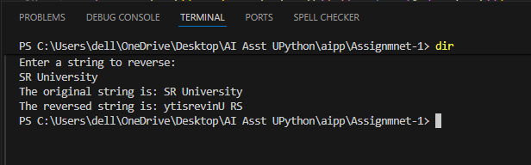

**Q4: Generate both recursive and iterative versions of a factorial function using comments**..

Code:

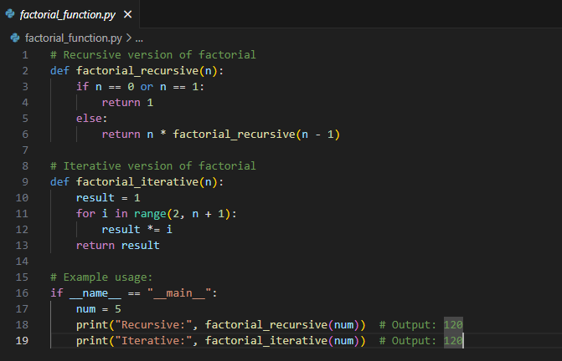

**Output: Two working factorial implementations**

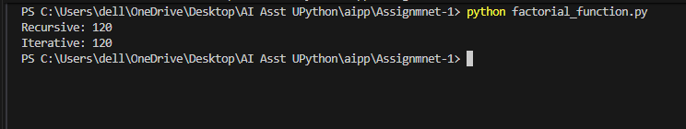

**Q 5: Use Copilot to find the largest number in a list. Assess code quality and efficiency**

Code:

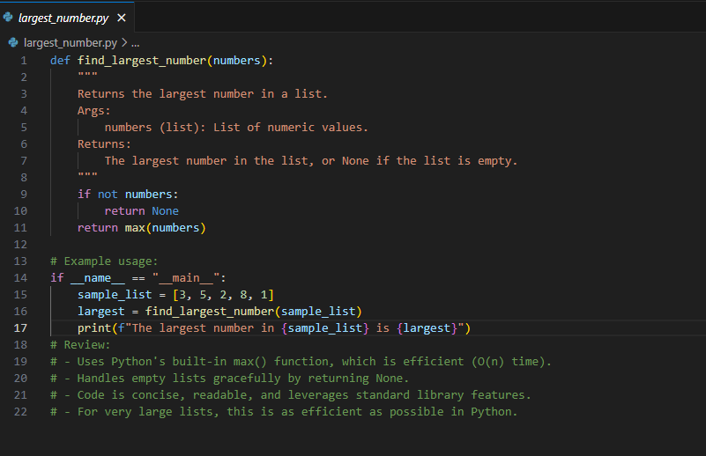

**Output: A valid function with your review**

